

**Catalog And Catalog Profile Creation**

Document Control

Prepared by:

|  |  |  |
| --- | --- | --- |
| Version | Date | Name |
| 1.0 | 01/22/2025 | ABHIJIT KUMAR |
| 2.0 |  |  |
|  |  |  |

Reviewed by:

|  |  |  |
| --- | --- | --- |
| Version | Date | Name |
| 1.0 | 01/28/2025 | NIKHIL KOOLWAL, SRINIVAS RAO PATHI, VIJAY PATIL |
|  |  |  |
|  |  |  |

Reference Documents

The following section describes relevant documentation:

|  |  |  |
| --- | --- | --- |
| Document Name | Description | Sharepoint Link |
| Catalog and Catalog Profile Creation | Steps for Catalog and Catalog Profile Creation | [CATALOG AND CATALOG PROFILE CREATION.docx](https://ts.accenture.com/:w:/r/sites/SAPIAMGlobalInstanceSetUp/Shared%20Documents/General/FY25/DEMO%20SCRIPTS/CATALOG%20AND%20CATALOG%20PROFILE%20CREATION.docx?d=w69884edb4a2848068f313bbc5a91d82d&csf=1&web=1&e=MKlNtR) |
|  |  |  |

Contents

1.Steps for catalog creation 4

2.Steps for Catalog profile creation 14

1.Steps for catalog creation

1. Log into the SAP system and navigate to transaction code bar and type code **‘QS41’** and press enter.

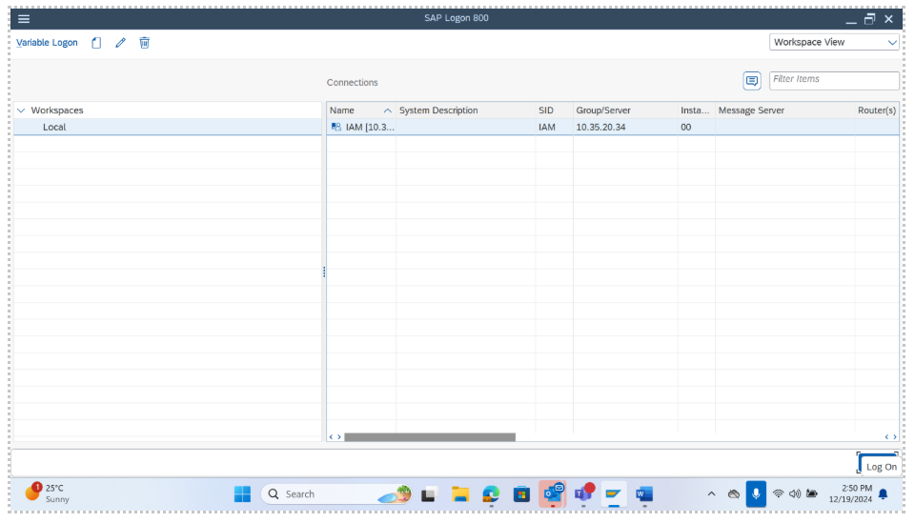

2. In the next page, catalog and code group needs to be filled.

For catalog field, codes can be selected from the list provided in the help option (i.e. 2 square options in the right) and for code group, any name starting with letter ‘Z’ should be given. After selecting catalog and giving code group, press enter key from the keyboard.

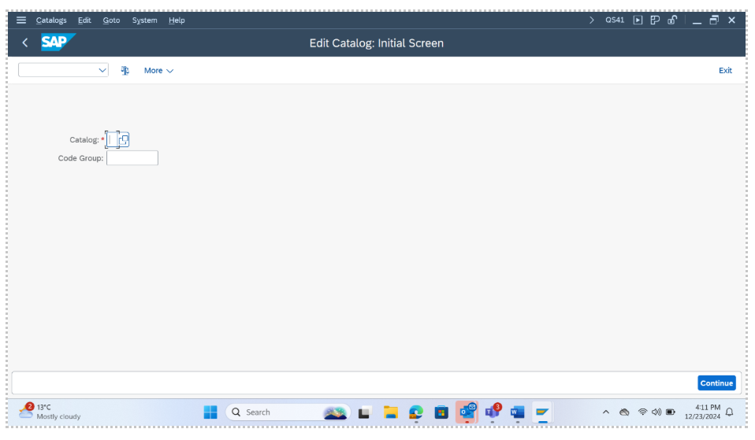

For e.g., here catalog selected is **B (Object Parts)** and code group is given as ZMOTOR.

1. Click on the space under short text right to **ZMOTOR** and give a short description to the code group. Then select the checkbox next to ZMOTOR and click on ‘codes’ under code groups in the left side.

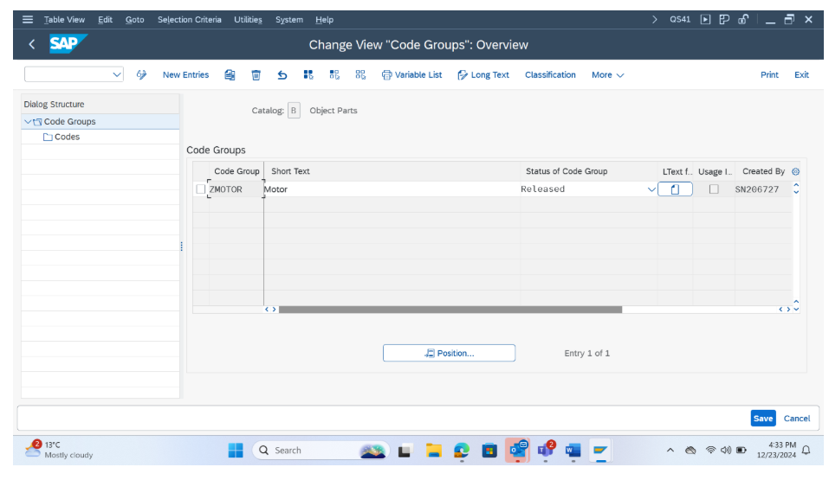

1. Select on the option ‘New Entries’ on the top, to add the codes and the short texts for the given selected codes.

1. After adding the desired number of new entries, click on the save button in the right-side bottom of the screen.

1. After clicking on save, it would redirect and show a prompt like the below screenshot. Click on the tick option to proceed and save the details.

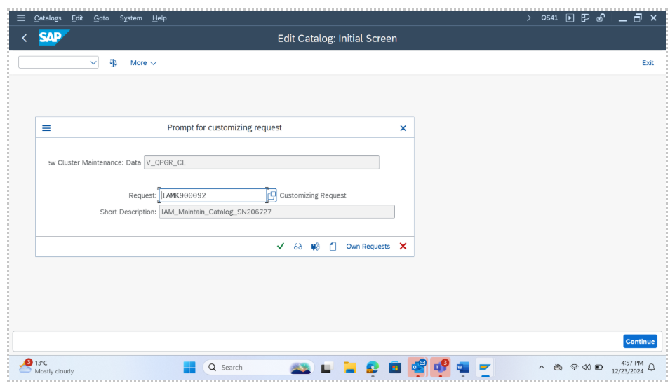

1. Similarly, the same set of steps (from step 1 to step 6) will be followed by changing the catalog value. **(Overview of Damages)**  
   For e.g. Catalog value is changed from B to C, 5, 2 and A respectively.

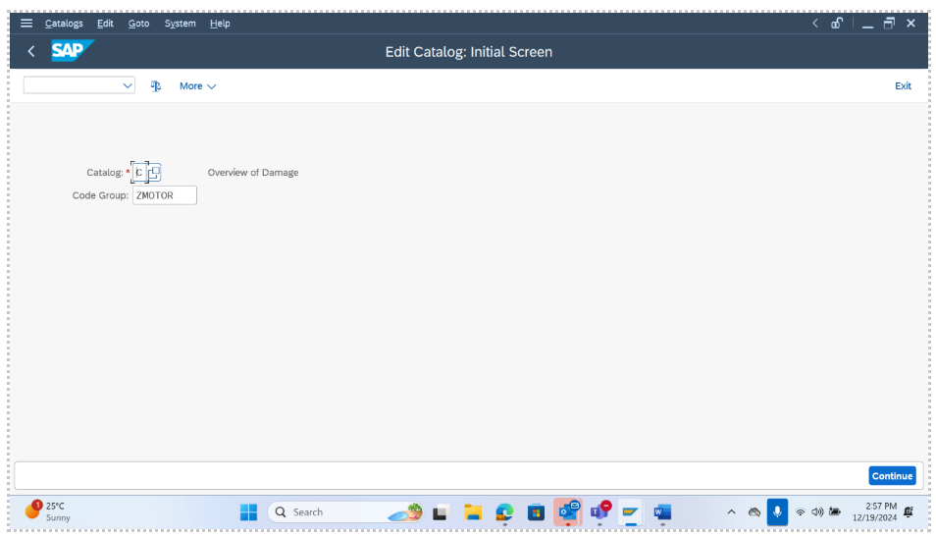

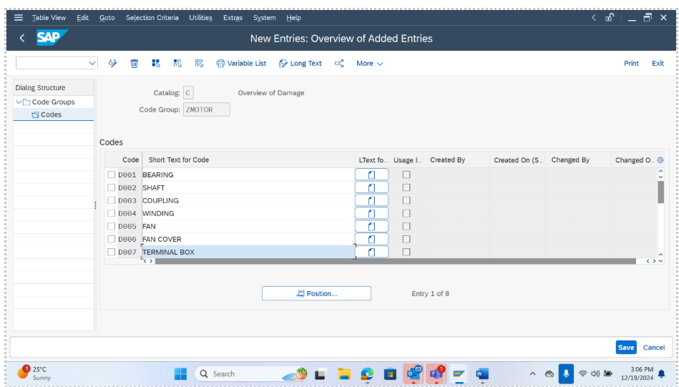

**Catalog 5- Causes**

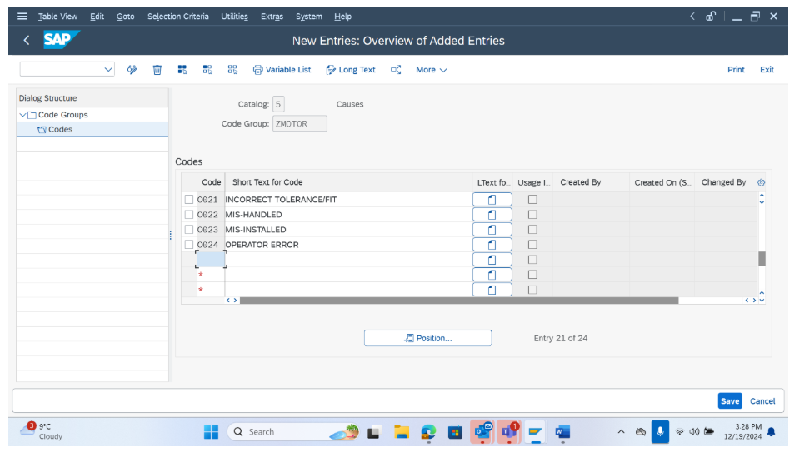

**Catalog 2 -Tasks**

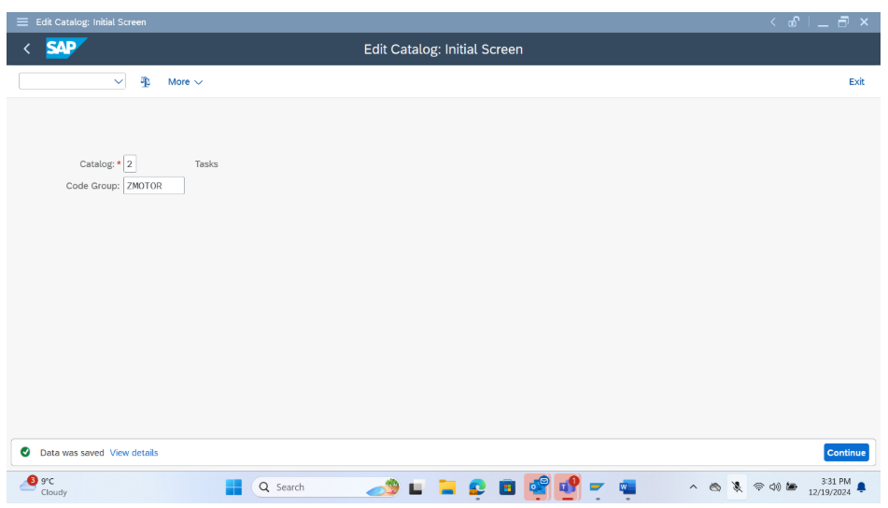

**Catalog -A Activities (PM)**

2.Steps for Catalog profile creation

1. Before starting the steps, one needs to ensure that the status of the catalogs previously created is being changed from ‘in progress’ to **‘released’**. For each code group, one must separately change the status. For e.g. in the bellow screenshot, the status of the code group is manually changed.

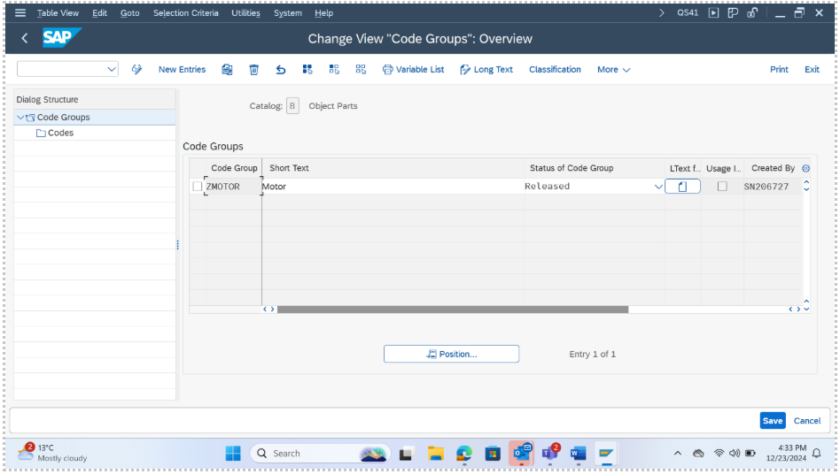

1. Now enter the transaction code OQN6.

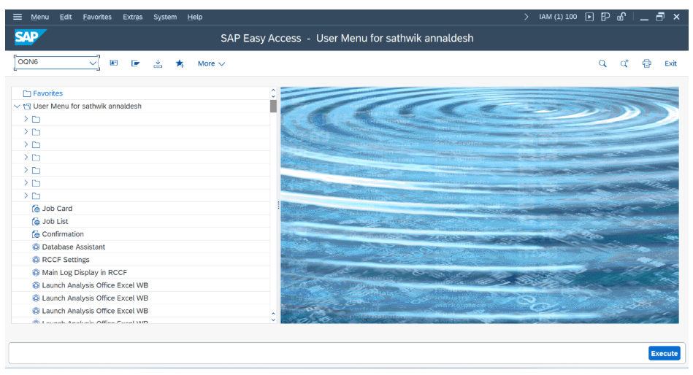

1. Click on ‘New Entries’

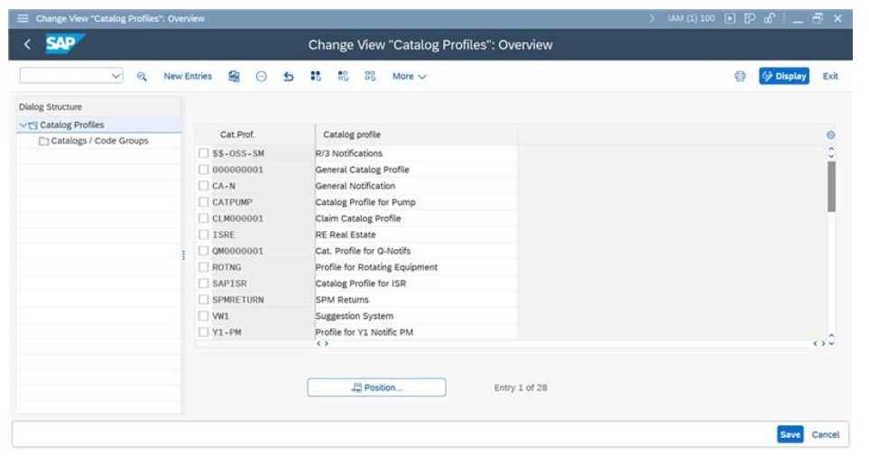

1. Enter the Code Group according to the need. Also provide short description to it.

1. Now, click on the check box left to Z_MOTOR and double tap on Catalogs/Code Groups in the left side.

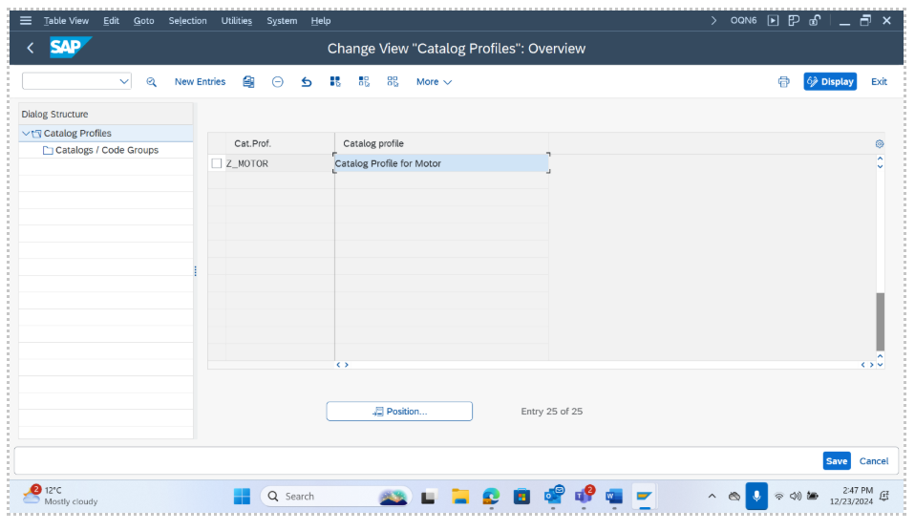

1. Click on new entries and add the required catalog and catalog group. After that click on save.

